FIS - Gaurav Jaybhay

1] Jenkins Dashboard.

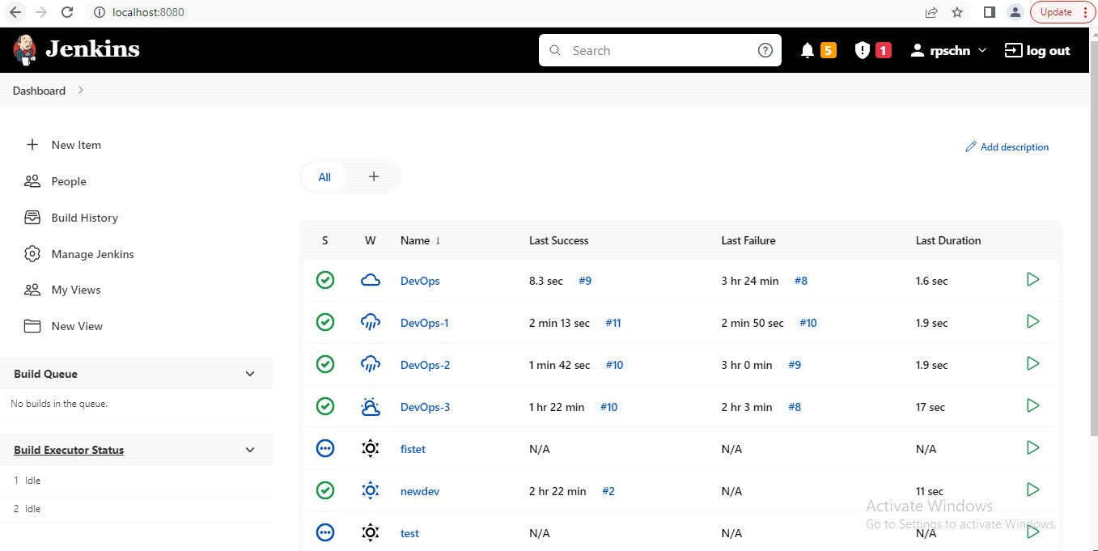

2] DevOps-1 for the fetching source code from github and integrate.

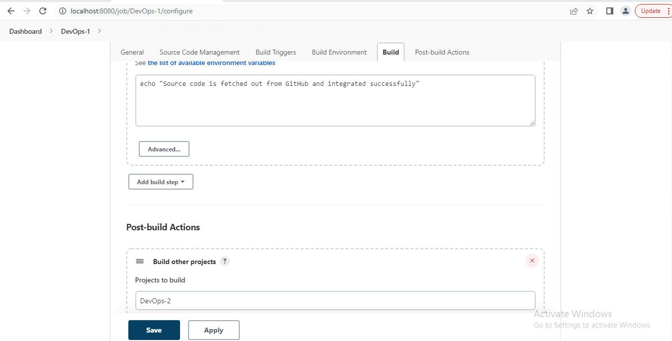

3] DevOps-2 for the building the jar file and stored it.

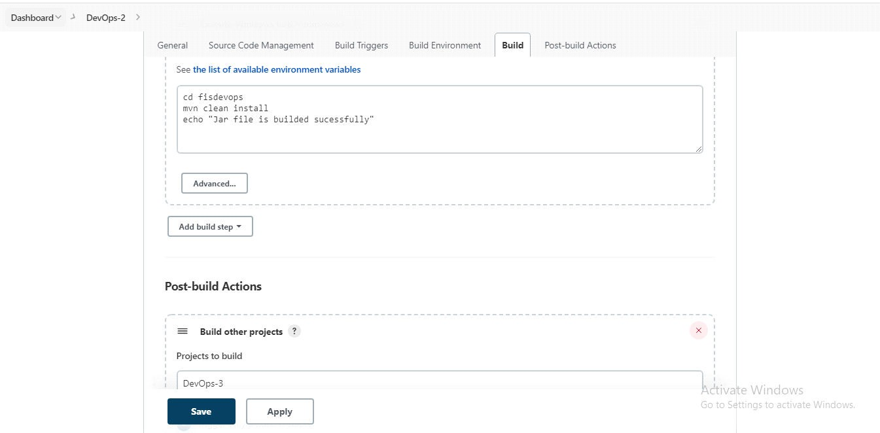

4] DevOps-3 building the docker image and running the container which is builded from that image.

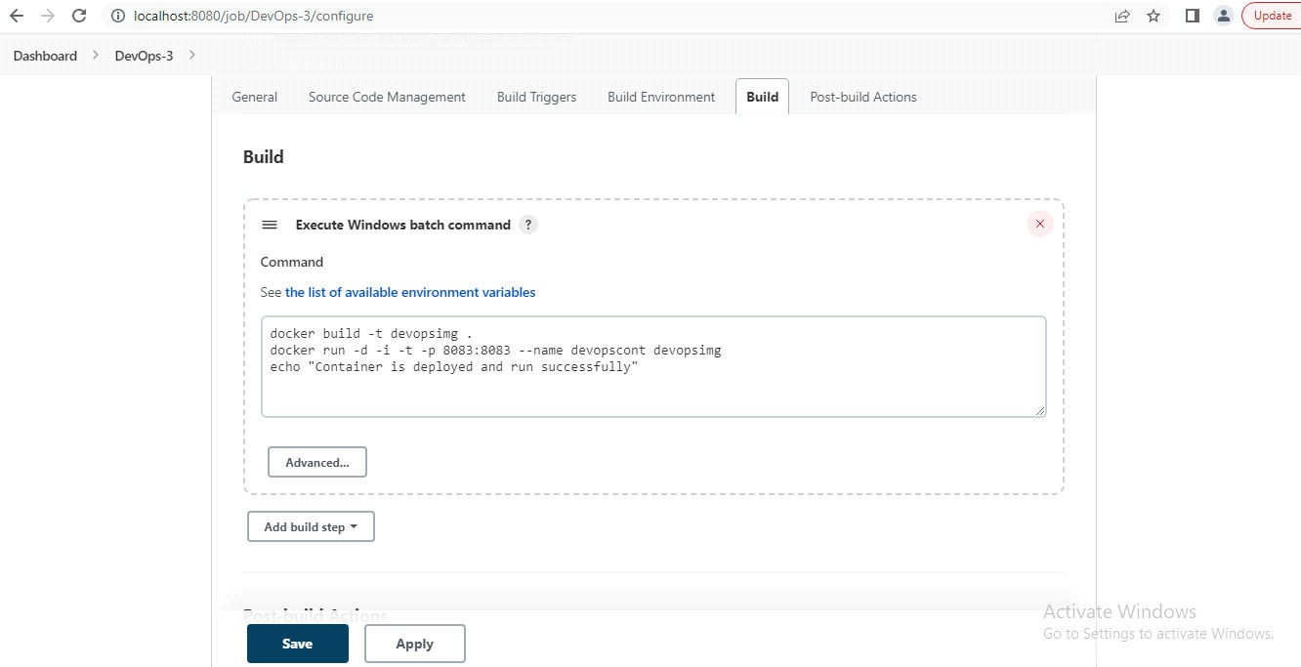

5] Docker Command promt to see created images and containers.

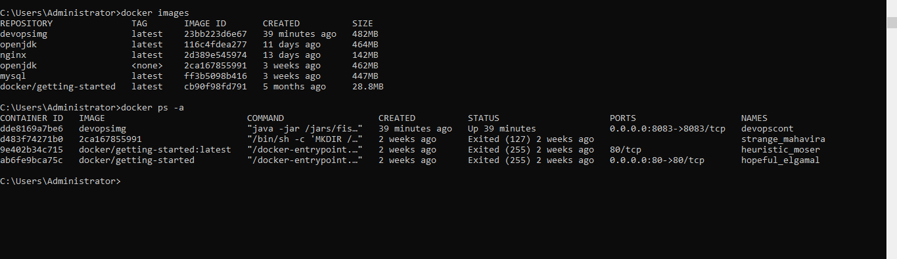

6] Project is working successfully with the help of Devops concepts.

